Problem–Solution Fit
Date | 27/09/2026
Team ID | SWTID-2026-8900
Project Name | Streamlining IT Procurement – Automating Standard Laptop Orders with Flow Designer

Problem–Solution Fit
The Problem–Solution Fit for “Streamlining IT Procurement: Automating Standard Laptop Orders with Flow Designer” focuses on identifying the challenges faced by employees and IT procurement teams when requesting standard laptops and designing an automated solution to address those challenges.
In many organizations, laptop procurement involves manual request submission, approval, verification, purchase processing, and status tracking. These activities can result in delays, repetitive work, communication gaps, and errors. By using Flow Designer, the laptop ordering process can be automated so that standard laptop requests are automatically routed through the required approval and fulfillment stages.
The solution aims to make laptop procurement faster, more accurate, transparent, and easier to manage while reducing unnecessary manual intervention by the IT team.

Purpose
- Solve procurement delays by automating the standard laptop request and approval process.
- Reduce manual work for IT and procurement teams by automatically routing requests to the appropriate approvers.
- Improve request accuracy by using predefined standard laptop options and required information fields.
- Speed up order processing through automated workflows and notifications.
- Provide better visibility by allowing employees and IT teams to track the status of laptop requests.
- Reduce communication gaps by automatically notifying users and relevant teams when the request status changes.
- Standardize the procurement process so that every standard laptop request follows the same defined workflow.
- Improve user experience by providing a simple and structured process for requesting a laptop.
- Increase operational efficiency by allowing IT staff to focus on exceptional or complex procurement requests instead of routine orders.
- Understand the existing procurement process and improve it by identifying repetitive activities, delays, and unnecessary manual steps.

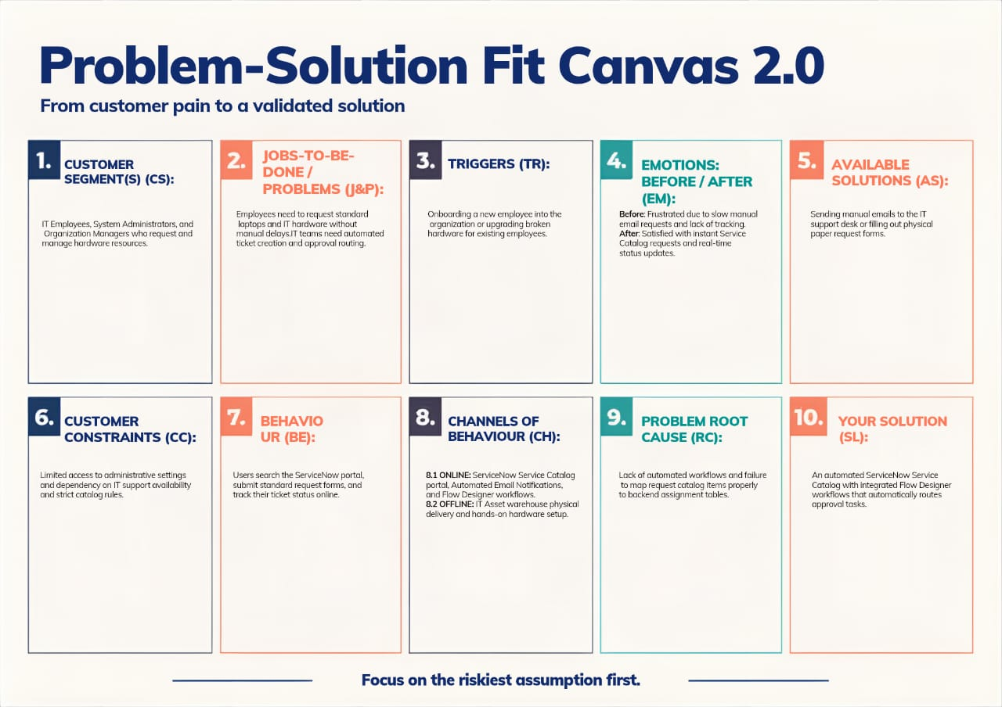

Problem–Solution Fit Canvas
Canvas Element | Content for the Project
Target Customers / Users | Employees requiring standard laptops, IT support teams, IT procurement teams, managers/approvers, and asset management teams.
Customer Problem | Standard laptop procurement is often handled manually, causing delays, repetitive tasks, approval bottlenecks, data-entry errors, and difficulty tracking requests.
Existing Situation | Employees submit laptop requests through emails, forms, or service portals. IT staff manually verify the request, obtain approval, contact procurement, and update the employee about the order status.
Customer Behavior | Employees repeatedly contact IT to check request status. IT staff manually review requests, send approval emails, update records, and communicate with procurement teams.
Pain Points | Long processing time, manual approvals, repeated communication, lack of real-time status visibility, human errors, and inconsistent processing.
Frequency of Problem | The problem occurs whenever employees request or replace standard laptops, particularly in organizations with a large number of employees.
Impact of Problem | Increased workload for IT staff, delayed employee onboarding or replacement, inefficient procurement operations, and poor user experience.
Proposed Solution | Use Flow Designer to automate the standard laptop procurement workflow from request submission through approval, fulfillment, notification, and status updates.
Automation Trigger | A standard laptop request is submitted by an employee through the service/request portal.
Automated Actions | Validate request → identify approver → send approval → process approved request → notify IT/procurement → update request status → notify employee.
Customer Benefit | Faster processing, reduced manual effort, fewer errors, improved transparency, consistent workflow, and better employee experience.
Value Proposition | A simple and automated laptop ordering process that reduces procurement time and manual effort while providing clear visibility into request progress.
Success Measures | Reduced processing time, fewer manual interventions, faster approvals, reduced errors, improved request tracking, and higher user satisfaction.

Problem
The existing standard laptop procurement process may require several manual steps such as collecting employee information, checking the request, obtaining manager approval, contacting procurement, updating records, and informing the employee.
This creates several problems:
- Requests may take too long to process.
- IT employees spend time performing repetitive administrative tasks.
- Approval requests can be missed or delayed.
- Employees may not know the current status of their request.
- Manual data entry can result in errors.
- Different IT employees may follow different procedures.
- Procurement teams may receive incomplete or delayed information.
Solution
The proposed solution is to create an automated laptop procurement workflow using Flow Designer.
When an employee submits a request for a standard laptop, the workflow automatically starts and performs predefined actions.
Automated Process

Employee submits laptop request
↓
Flow Designer triggers workflow
↓
Request details are validated
↓
Approval request is sent to manager
↓
Manager approves/rejects request
↓
Approved request is forwarded for fulfilment/procurement
↓
IT/Procurement team processes the order
↓
Request status is automatically updated
↓
Employee receives notification
↓
Laptop request completed

Problem–Behaviour Fit
The system addresses the actual behaviour and difficulties of the users.
Problem / Behaviour | Automated Response
Employee manually contacts IT to request a laptop | Provide a structured request form
IT manually checks every request | Automate validation of required information
Manager approval takes time | Automatically send approval request
Employee repeatedly asks for updates | Send automatic status notifications
IT staff manually update request status | Automatically update workflow stages
Procurement receives incomplete information | Use predefined standard laptop request fields
IT staff spend time on repetitive tasks | Automate routine procurement activities

Expected Outcome
The implementation of Flow Designer is expected to transform the standard laptop ordering process from a manual and time-consuming activity into a structured and automated workflow.
The solution can help the organization:
- Reduce laptop procurement processing time.
- Minimize repetitive IT tasks.
- Improve approval efficiency.
- Reduce human errors.
- Provide better request visibility.
- Improve communication between employees, managers, IT, and procurement.
- Create a standardized procurement procedure.
- Improve the overall employee experience.
Problem–Solution Fit Statement
Employees need a faster and more transparent way to request standard laptops, while IT teams need to reduce repetitive manual procurement activities. Automating the laptop ordering process with Flow Designer provides a standardized workflow that manages approvals, notifications, status updates, and fulfillment efficiently.
This gives your project a clear problem → user behavior → solution → benefit connection, which is the main purpose of the Problem–Solution Fit canvas.

